Drama Lesson Portfolio
Grade level: Grade 2
Theme: Life cycle
Title: The Wonderful Life Cycle of Butterflies

TEKS:

Science TEK: §112.13. Science

(10)How organisms survive in their environment. Students are aware that organisms have structures and mechanisms that enable them to survive in the environment they inhabit. Students must: (1) identify the physical characteristics in the organisms and note how they can meet their basic needs by observing their behavior. (2) Make a physical comparison of the physical characteristics of the animals on how they meet the necessities. (3) Identify and note down all the stages the insects undergo throughout their life cycle.

Art TEK: §117.107. Theatre

The student is supposed to come up with ideas about self-human associations and the surrounding environment using drama components and theatre conventions, have self-assurance and awareness of oneself throughout the play, use animated and recurrent movements which portray the student is aware of what she is performing, mimic sounds and movements and also create a living and non-living objects by imitating in the theatrical play.

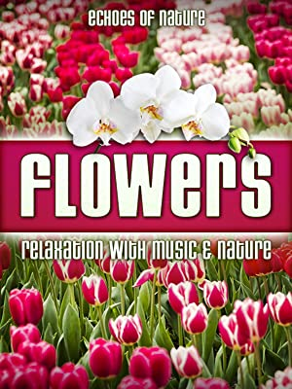
- CD:

I choose the CD 'Flowers relaxation with music and nature' by Liam Dale. I will play the music to help children concentrate and have more energy as we generate movements in organisms' lifecycle. The music contains beautiful melodies about nature, and it is relaxing and peaceful
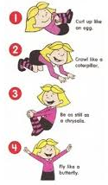
Movements
- Whorl up like an egg
- Creep like a caterpillar
- immobile as a larva
- Hover like a butterfly

3325 Template of the Lesson Cycle
A leak up of the previous lessons of the life cycle movements | I will assemble my students into one large group and ask them, 'who can remember about the butterfly movements in a lifecycle and the lessons we learned last week?'…' Who can be able to create that with his or her body?’. Once they can give correct answers, I will guide them on the full life cycle.
Topic | I want us to study the full lifecycle of a butterfly, as I had earlier said. We will do this by moving using our whole body.
Teach and demonstrate | I will ask each of the four stages of a butterfly's lifecycle; once they mention, I will demonstrate by either coiling or flying depending on the stage. I will also ask them to make the movements as they imitate whatever I do. Then I will play the music CD and ask them to reflect on the four lifecycle stages. I will also ask them to create other desired movements apart from what I had demonstrated to them. They will actively engage themselves in the activities even after dismissing them into their classrooms and helping those who need guidance.
A review of the lessons to test understanding | I will ask students to show us the movements they created on their own and review what we had learned last time. It will test the understanding of the four stages of the butterfly lifecycle.

Visiting Artist: Shara Phillips

I will contact Shara Philips, a proficient dancer, to join me in the lesson and help my students create dance moves. She is an instructor who has trained in a variety of dance and makes the right dance moves. She is a Bachelor's degree holder of Fine Arts from Sam Houston State University. Shara has been teaching dance for several years; hence I believe she will be a perfect fit to teach my students whole-body movements.

Floorplan:

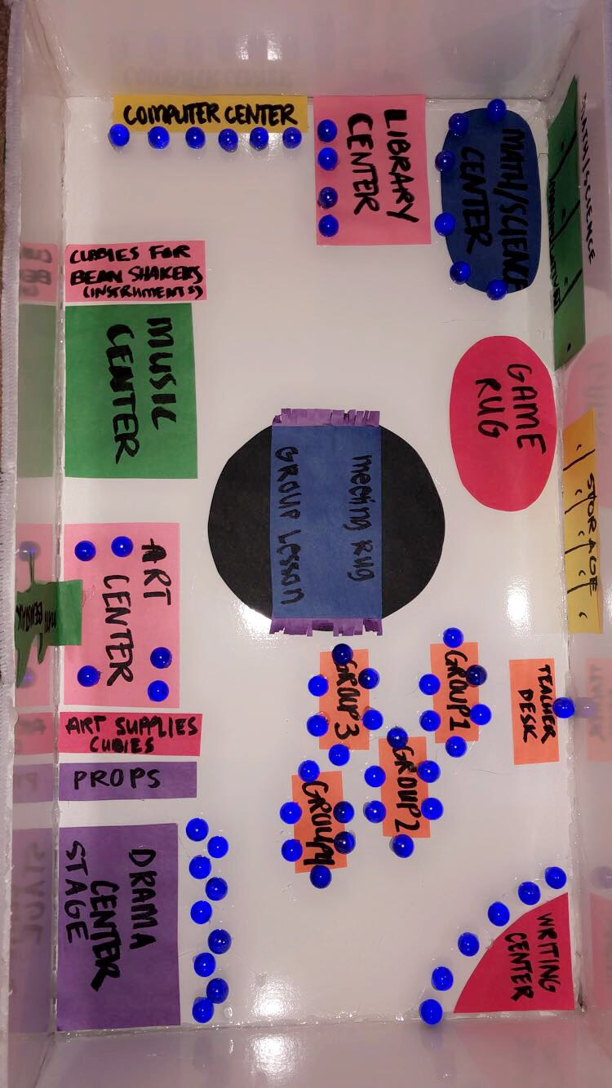

In this floor plan, I will subdivide students into groups to showcase their movement skills across a butterfly's four life cycle stages. I will also provide them with materials to actively engage themselves in the roles given to them.
Purpose of the center
The center part aims to ensure that all students are actively engaged in the movements, and no student is left out. It will also enhance all the students and those on stage performing, and the observers. They will be creative and development roles to be distributed among them for active participation in the group.
The skills students will develop.
Creativity is one of the skills students will develop. They will use creative thinking to create roles. They will also develop teamwork through collaboration by sharing roles and deciding who will play this role. Students will also gain communication skills by discussing the role plays.
Materials needed
Materials to be used include glue, papers, sticks, mark pens, sunglasses, cameras, baby dolls, shoes, writing materials.
Guidelines
- Students will listen and adhere to the teacher's instructions on how to play the drama.
- Students will take care of the materials provided to them.
- Students will assemble all the materials at the back to create space at the center.
- Students will attentively listen and follow the performer’s instructions.

Assessment
Assessment will test the students' understanding and comprehension over the four stages of a life cycle. I will ask them questions related to the lifecycle as I play music on the CD. They will also imitate actions and make movements. I will award them points according to how they respond and perform. For example, a student who will imitate all the four stages will get four points, while the one who gets three will award him or her three points. I will also ask them to create new movements they might have invented related to the four stages and earn extra points.

Student’s Name | 1 | 2 | 3 | 4 | Extra points
 | Imitated one stage of the life cycle | Imitated two stages of the life cycle | Imitated three stages of the lifecycle | Imitated all the four stages of the lifecycle | Was able to develop or create new movements

